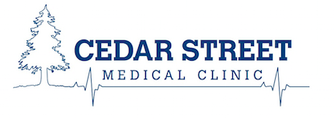

Item | Fee
Examinations
Drivers medical under 80 years | $125
Drivers medical over 80 years | $50
Complete physical for insurance/work | $200
Physical fitness for school/camp | $50
Private office visit (no MSP coverage) | $70
The above fees include the accompanying paperwork
Travel Medicine
Travel medicine counseling | $50
Procedures
Liquid nitrogen | $20 for 1, $30 for 2-5
Cosmetic excision up to 5cm | $150
Second lesion | $50
Cosmetic excision on face | $250
Prescriptions
Renewal of prescription by phone or fax | $30
Forms
Letter for work/school absence | $15
Insurance company forms | $30/page
Written certificates | $30/page
Drug benefit form for third party | $50
There will be a review of records fee in addition to the above when deemed appropriate
Review of records | $60/15min
Transfer of records
Transfer of patient records | $30
Photocopying fee | $1.7/10pg then $0.3/pg
Disc | $5
Medico-Legal Fees
Short form regarding patients condition | $167
Medico-legal form (short) | $352
Medico-legal report (in depth) | $1,053
Medico-legal opinion (report +opinion) | $1,761
Review of records for medico-legal purposes | $98.4/15 min

